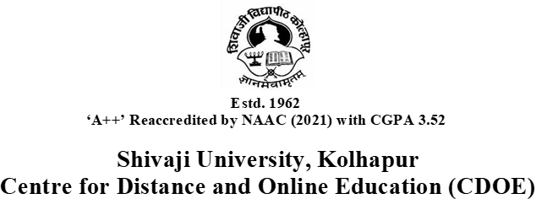

Guidelines for Viva Voce Presentation

Dear students,
Following guidelines to be followed during the presentation of Viva Voce:-
- Your viva voce will be conducted through online mode.
- 10–12 minutes per student for presentation with 20-22 slides.
- 5 minutes for question–answer session (may vary slightly depending on the expert).
- You may use: PPT shall be in Pictorial presentation, Diagrammatic presentation etc.
- Only 2–3 colours allowed in the entire PPT and it can be used only for titles or subtitles.
- Present hypothesis testing only in table or graph format.
- Following points to be covered in PPT presentation: -
- Title page (Project title, Student Name, Guide Name, Centre name and Year )
- Introduction
- Importance and Significance of the Study
- Hypotheses (if any)
- Scope of the Study
- Review of Literature
- Profile of the Company/organisation
- Objectives of the Study
- Research Methodology: Research type, Research method, Data collection tool and technique, Data type, Data analysis tool and technique
- Findings
- Suggestions
- Conclusion
- References

